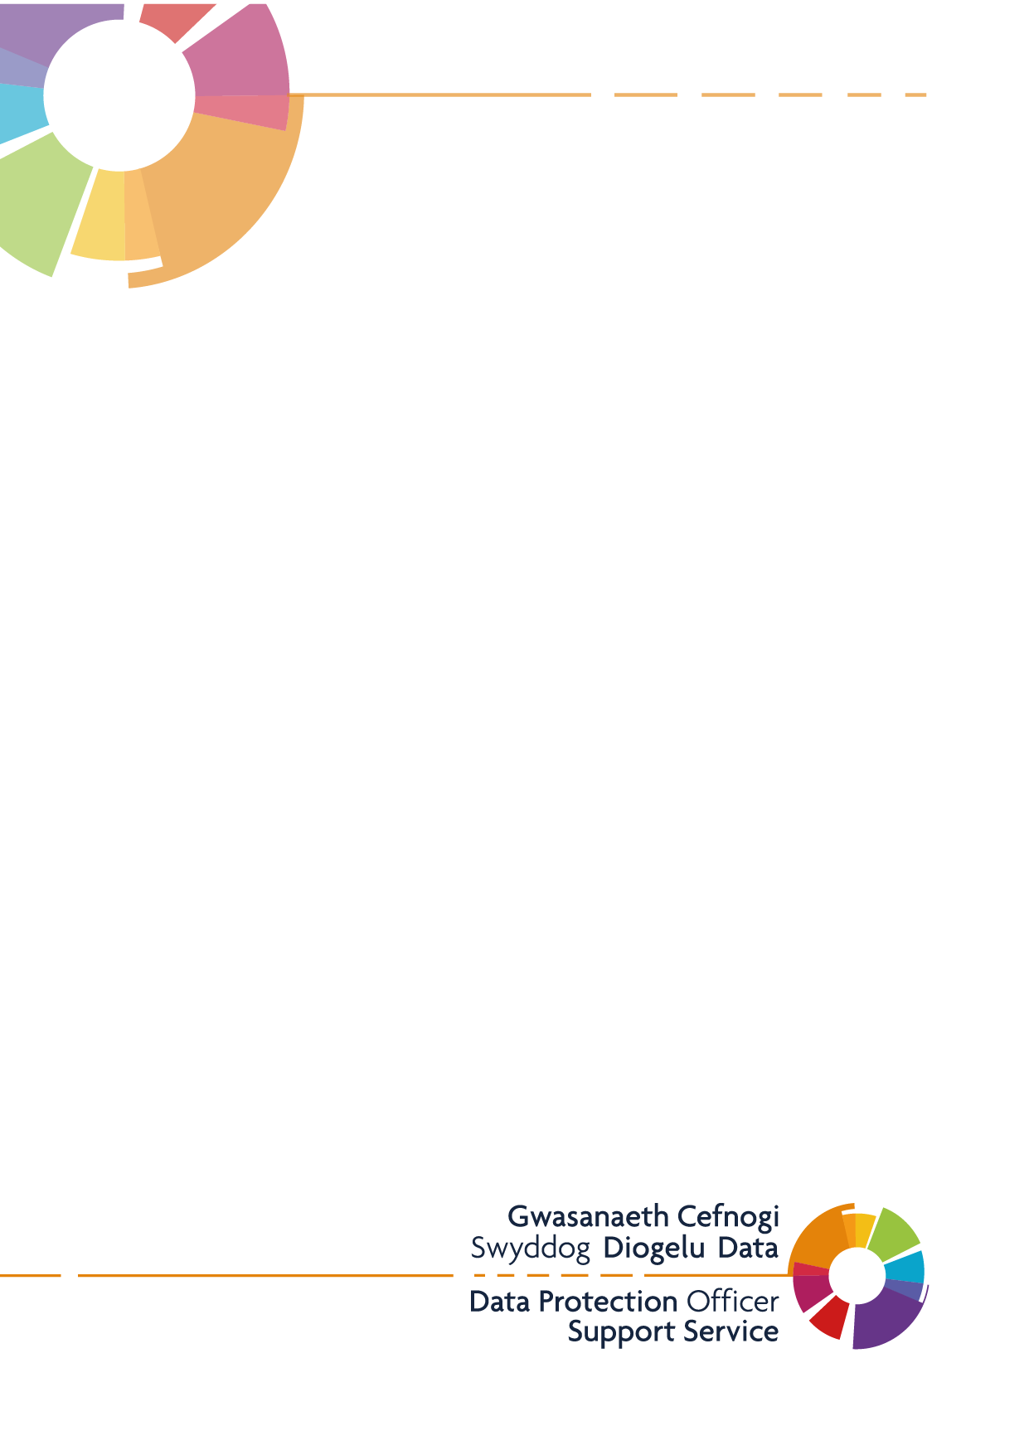

Individuals Rights

Request Form
St. Thomas Surgery and West Cross Medical Centre

Individual Rights Request Form
Application to exercise your Individual Rights regarding the way St. Thomas Surgery and West Cross Medical Centre processes your personal data
NOTE – It is not compulsory for you to complete this form; however, it will help us deal with your request more efficiently.
This form can also be used if you are making a request on behalf of someone else, however in such instances we will ask you to provide evidence of your entitlement to act and receive information (please ensure you complete section 3) or will seek authority from the individual for whom you have made the request.
You will not be charged for your request. However, the Practice can charge a reasonable fee when a request is manifestly unfounded or excessive, particularly if it is repetitive. We will therefore charge a fee to cover administrative costs where further copies of the same information are requested.
If you have any queries relating to your request, please contact Dawn Lloyd Practice Secretary
Your Individual Rights
Subject to certain exceptions, you have various rights regarding the way St. Thomas Surgery and West Cross Medical Centre holds your data. If you wish to exercise these rights, please select the relevant option.
How would you describe your relationship with the practice?
☐ I am a patient
☐ I am a previous patient
☐ I represent a staff member
☐ I am a former employee
☐ I am a service user
☐ I am a representative of a patient/former patient
What would you like the practice to do?
☐ Provide me with a copy of personal data
☐ Have inaccurate information amended
☐ Have my information deleted
☐ Stop the processing of my data

*There are certain conditions that must apply to exercise your right to restrict the processing of your data, to exercise your right to have your data erased and to object to the processing of your data. Please see Annex A for full details

Please complete the following sections carefully and follow the instructions regarding the provision of proof of identity and details of how to return the form to the practice.
Section 1 – Details of the data subject (who the personal information relates to)
Title:
Surname
Forename(s)
Address
Postal Code
Date of Birth
NHS Number (if known)
Contact Telephone Number
Email address
Section 2 – Details of the request
Please provide as much detail as possible as to the data you are requesting, or actions relating to restriction, erasure, rectification, or objection.
Please be as specific as possible as this will speed up the request process, include time periods and specific episodes of illness or treatment wherever possible.
Are there any specific dates you require this information to relate to?
Please state:

Section 3 – Identifying the data subject (who the personal information relates to)
Yes, I am the data subject  Please go to Section 5 | No, I am not the data subject  Please go to Section 4

Section 4a - Details of the individual requesting the information
Full Name
Address
Postal Code
Date of Birth
Contact Telephone Number
Relationship to individual for whom you are requesting data:

Section 4b - Relationship to data subject
Please describe your relationship with the data subject and the reason that leads you to make this request on their behalf:

Section 4c - Authority to release information
A representative will need to obtain authority from the data subject before personal data can be released. The representative should obtain the data subject’s signature below or provide a separate note of authority.
If the data subject lacks capacity to give authority in this way, the representative should provide evidence of the authority that it has, such as proof of parental responsibility for children under 12 or Lasting Power of Attorney (LPA).

Should this request be in relation to deceased records, proof of LPA will need to be provided or evidence that the representative has a claim arising from the deceased’s death.

I hereby give my authority for the representative named in Section 4a of this form to make a Subject Access Request on my behalf under the UK General Data Protection Regulation

Two pieces of identification are also required (please see section 5)
Signature of Data Subject: | Date:

Section 5 – Proof of identity and authority
In order to prove the data subject’s identity, we need to see copies of two pieces of identification, one from List A and one from List B below.
In addition, if you are acting on the data subject’s behalf, we will need evidence of appropriate authority, List C for parental requests for children under 12, or List D for individuals who are deceased or lack mental capacity.
List A (one from below)  Passport – must be valid  Driving Licence – must be valid  Resident permit issued by the Home Office  EEA/EU Identity Card – must be valid  If none of the above are available:  Birth Certificate or Adoption Certificate – must be valid original or a copy from the General Register Office (NB we can accept the short version or the full version)  Valid Armed or police forces photographic identity card  Photographic disabled blue badge | List B (one from below)  Bank/Building Society/Credit card statement – Issued to the current address and less than twelve months old  Pension/Endowment/ISA statement – Issues to the current address and less than twelve months old  Utility Bill (not mobile phone or TV Licence) – Issued to the current address and less than twelve months old  Council tax bill/Mortgage statement – Issued to the current address and less than twelve months old  Hospital appointment letter  Recent mortgage statement from recognised lender | List C (one from below)  Birth certificate  Adoption certificate  Court Order  All of the above must name the requester as an individual with parental responsibility | List D (one from below)  Lasting Power of Attorney  Evidence of a claim arising from the death of the deceased - only information relevant to the claim will be disclosed

Section 6 – Declaration
The information which I have supplied in this application is correct, and I am the person to whom it relates or a representative acting on his/her behalf. I understand that St. Thomas Surgery and West Cross Medical Centre may need to obtain further information from me/my representative/the data subject to comply with this request.

Signature: ……………………………………..…………

Date: ………………………………………………………..

Please return the completed form along with two pieces of identification to:

St. Thomas Surgery
Ysgol Street
Port Tennant
Swansea
SA1 8LH

*For internal use
Yes
Sufficient evidence has been provided to verify requester’s identity

Yes N/A
Sufficient evidence has been provided to verify requester’s identity and proof of authority

Annex A – Set criteria to exercise your rights
- Request the practice restrict the processing of your data
Your right to restrict data processing only applies in the following limited circumstances:
    - There is a query about the accuracy of personal data we hold and only for a period to enable us to verify its accuracy
    - The processing is lawful but instead of deletion you wish to restrict its use
    - The information held about you is no longer needed for its original purpose
    - You have objected to us processing the personal data, in which case processing can be restricted whilst we verify the processing required and our basis for doing so overrides your objection.
- Request the practice to erase data held about you
Your right to have data erased only applies in the following limited circumstances:
- Your personal data is no longer required for the purposes it was originally collected
- The basis for processing your data is consent and you have withdrawn consent
- The basis for processing your data is for our legitimate purposes, but our reason does not override your interests
- Personal data is being processes for Direct Marketing purposes and you object to that processing.
- We have processed your personal data unlawfully
- There is a legal obligation to erase data for example a court order
- Data is being processes to offer certain digital services to a child
In most cases, the practice does not process your data or relay on any of the limited circumstances that would allow data to be erased. The Practice is required to ensure it keeps your records in line with the Public Records Act 1958, for public health purposes, including to ensure that you are provided with the correct healthcare treatment.

- Object to the processing of your personal data.
Your right to object to processing only applies to the following types of personal data:
Type of Processing | Right to object
Direct Marketing (including Profiling) | You have an absolute right to object
Processing we carry out based on legitimate interest or in the public interest or under official authority | You can object at any time on grounds relating to your situation. We do not have to comply if we have legitimate grounds for the processing
Processing that we carry out for scientific or historical research or statistical purposes (except where the processing is necessary to carry out a task for public interest reasons | You can object at any time on grounds relating to your situation. We do not have to comply if the processing is necessary for the performance of a task carried out for public interest reasons

