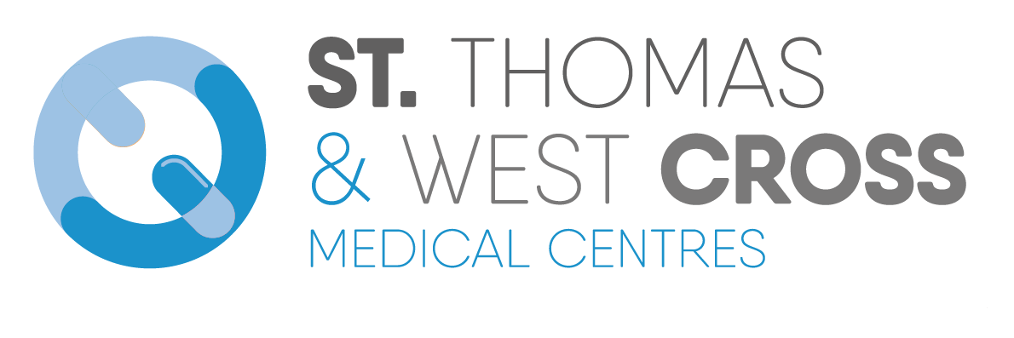
Practice Leaflet

Practice Information

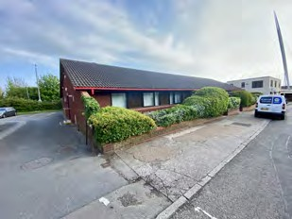

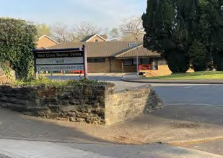

01792 653992
St. Thomas Surgery

Ysgol Street St. Thomas Swansea
West Glamorgan SA1 8LH

West Cross Medical Centre

82 West Cross Lane West Cross Swansea
West Glamorgan SA3 5NG

01792 457148

Access to the surgeries is provided for the disabled.

There is an adapted toilet availa- ble for patients' use as required.

A hearing loop is available at reception. If you require BSL support to attend with you for an appointment, please contact:

Wales Council for Deaf People Tel: 01443 485687 or
e-mail: mail@wcdeaf.org.uk

www.stthomaswestcross.co.uk

enquiries.w98016@wales.nhs.uk

The surgery website is the most effective way of giving our patients access to help and the latest information 24 hours a day, seven days a week. It contains complete information about all the services we offer. It also details how the practice is organised and introduces our doctors, other medical and administrative staff and describes their various responsibilities.

Welcome

We are proud to have a mixture of professionals working with us, these include salaried doctors, nurses, a health care worker and a paramedic practitioner. Our staff are trained to help you with your health needs and to give a personal face to the services we offer.

We operate out of two sites in Swansea. We have one surgery in St. Thomas and we also have a branch surgery in West Cross. The service we provide is carefully planned to attempt to meet the special needs of the community and we welcome constructive suggestions on how it may be improved.

We are a member of the Bay Health Cluster Network. The practices in the cluster network work co-operatively to use specialist skills and shared resources to improve health and education across the locality. To find out more about our Cluster Network please visit the Bay Health Cluster Network website.

Local Health Board
Details of primary medical services in the Swansea area may be obtained from:
SBU Health Board, 2nd Floor, Beacon Centre for Health, Langdon Road, Swansea SA1 4QY Telephone: 01792 601800

The Partners
Dr W Ioan Thomas (m)
MB BCh (University of Wales) PGDip MRCGP

Dr Kirstie H Truman (f )
MB BCh (University of Wales) MRCGP MSc GP Trainer

Dr Lisa J Adams (f )
MB BCh (Cardiff University) B Pharm (London) DRCOG, MRCGP GP Trainer

Dr Matthew Giles (m)
MB BCh (Cardiff University) MPhil PGDip DipMSKMed MRCGP MFSEM GP Trainer
Some of our staff are welsh speakers. If you prefer to communicate in Welsh, please let our reception team know.

The doctors practice together as a non- limited partnership.

We have a range of multidisciplinary staff who work across both practice sites. These include salary doctors, doctors in training, nursing staff, and a paramedic practitioner.

Salary Doctors
Dr. Claire Williams (f )
Dr. Sunniva Nicholas (f )
Dr Melanie Blyth (f)
Dr Colman Chiu

Nursing Staff
We have four highly trained practice nurses who hold a range of post-graduate qualifications. They are always available to offer advice and support.

Helen Cooper Donna Davies Helen Jones Kate Hancock
Medical Students
We undertake a program of teaching medical students and express our thanks to all our patients and staff for their co-operation in this process. A strict protocol is followed: the receptionist will inform a patient that a student will be present and will seek consent before the consultation starts.

Advanced Nurse Practitioner
We have an ANP, Jessica Huntley, who runs chronic disease clinics as well as helping with urgent care.

GP Training
Our practice is a training/teaching practice. Our GP registrars are fully qualified and have a great deal of hospital experience. Registrars are attached to our practice for four, six or twelve months and patients often find their fresh, enthusiastic approach complements to the service we offer.

The registrars usually become general practitioners after completing their training, and are at all times encouraged to seek advice, when required, from the practice partners. As part of the registrars’ training and examination process, there is a requirement to video a number of consultations. Your written permission would always be sought for this.

Practice Manager
The practice manager, Sandra Kiley, is respon- sible for the administration of the practice and is happy to hear your views and sugges- tions about the service offered by the practice.

Reception team / secretary
The staff behind the reception desk will assist you in making appointments to see your doctor, organise repeat prescriptions, give out test results and answer numerous and varied questions.

It is a legal requirement that confidentiality of patient’s records is maintained at the highest level by all staff.

Attached Staff
The Swansea Bay University Health Board employs pharmacists, district nurses and health visitors that regularly work with us to help deliver your care.

PHARMACISTS

The practice has a team of pharmacists who will see patients on our behalf for medication reviews, polypharmacy reviews, blood pressure management and anticoagulation.

DISTRICT NURSES

The district nursing team consists of sisters, staff nurses and enrolled and auxiliary nurses. The nurses are based in a Local Central Hub.

Their duties include visiting patients of any age in their homes, giving practical assistance or offering professional advice. Each patient’s needs are assessed and the care and treatment is planned accordingly. District nursing sisters are experienced registered general nurses with a certificate or diploma in district nursing.

If you need a district nurse to visit you at home, or for any other district nursing enquiries, you can contact them on 01792 636007.

HEALTH VISITOR

The health visitor is a specially qualified nurse who can provide information, advice and support to families with children. It is part of their role to visit children under five and they are available in the surgery at their regular baby clinic.

The health visitor may be contacted on 01792 653992.

Patients are registered with the practice and not an individual doctor.

To register, simply complete a registration form. These forms are available at the reception desk or can be downloaded via our website. You will be advised to provide identification.

You will be required to fill in a short medical questionnaire and attend for a new patient medical check. This is necessary for us to obtain any important health information and record any current medication etc. New patients will be issued with an invitation to a consultation with a doctor or an appropriate member of the practice team. This should occur as soon as possible following registration.

NHS App
The GP Practice provides this service in collaboration with NHS Wales.

Once you’ve created an account you will be able to use the features the GP practice has made available, which may include:

Book and cancel appointments Request repeat prescriptions Update personal information

Before being able to create an account you must first download the app and register.

As part of the registration process you will be asked to prove your identity. This is one of the measures in place to protect the information that the GP practice holds about you. Full details about the process are available online Login screen (nhs.wales).

Temporary Residents
If you are away from home and need medical attention you may consult a doctor anywhere in the UK. If you have a relative friend staying with you on a temporary basis, who is eligible for treatment we will be happy to see them should they need to see a doctor or nurse. Please contact the surgery should you require further information.

How to make a routine appointment
You can make an appointment by
Phone 01792 653992 after 12pm to book routine appointment
Via the NHS app Please ask staff for more details about registering (available from 14th March 2024)
At the reception desk of either site.

Please book routine appointment in advance for any non-urgent matters
Appointments are available up to 4-6 weeks in advance
Web appointments available for booking online from April 2024 via NHS app
Please book routine appointment in advance for any non-urgent matters

Urgent & Emergency Appointments

We operate a telephone Triage System to ensure acutely unwell patients are assessed on the day by a clinician

Our reception team will ask specific questions to patients requesting urgent on the day appointments, this enables the clinician team to assess the urgency and appropriate action required i.e. telephone call back or face to face consultation.

Reception staff are trained care navigators and can advise on alternative local services available i.e. Physio self-referral, Pharmacy, Minor ailments schemes, Mental Health, NHS 111, Social prescribing, Community coordinators, Details for all these local services are available on our surgery aa/webpage.

The practice offers all patients all patients a comprehensive and efficient service to ensure the correct treatment is offered by the healthcare professional the clinically appropriate timescale.

Opening Times
The telephone lines are open 0800 - 1830 on 01792 653992 for both sites.

St. Thomas Surgery is open 08.30 - 1830 Monday to Friday.

West Cross Medical Centre is open from 0900 - 1800 Monday, Tuesday, Wednesday and Friday. West Cross Medical Centre closes at 1300 on a Thursday.

Consultation Times
Monday – 0800 - 11.55, 1400 - 17.50
Tuesday – 0800 - 11.55, 1400 - 17.50
Wednesday – 0800 - 11.55, 1400 - 17.50
Thursday – 0800 - 11.55
Friday – 0800 - 11.55, 1400 - 17.50
Saturday – CLOSED
Sunday – CLOSED

Out of Hours

Home Visits
Patients requesting a home visit will be contacted by a senior doctor to assess the urgency of the situation and offer advice where needed.

Please telephone the receptionist before 10.30am to request a home visit. You will be asked for details of the problem to allow the doctor to assess the urgency of the request.

The doctor may arrange a home visit for a patient where the medical condition is so severe that they are unable to attend surgery. Home visits are usually undertaken by our paramedic, Andrew Jones.

We do not consider lack of transport suffi- cient reason to request a home visit. The ability to properly assess and treat a patient in their own home is often impaired by the non-ideal clinical environment as well as a lack of equipment. It is often safer for a relative, friend or taxi to transport the patient to the surgery to attend an urgent appointment.

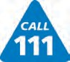
If you need to see a doctor between the hours of 6.30pm and 8.00am weekdays, Saturday, Sunday and up to 8.00am on Monday, please contact the out-of-hours service on telephone number 111. The number is free to call. You can also ring 111 if you need health information and advice.

NHS Direct Wales is a 24 hour service available if you need health information or advice visit www.nhsdirect.nhs.uk

Ordering prescriptions Collecting prescriptions
Repeat prescriptions can be ordered in

three ways:
- by using My Health Online
- by ticking the appropriate medication on your counterfoil and leaving it at the surgery
- via phone during opening hours
Prescriptions will be ready for collection 48 hours after they are requested.

You may arrange collection and delivery with a pharmacy of your choice.

Getting test results Change of details

Results of blood tests can be requested after five working days

Results of imaging investiations can be requested after ten working days
Please inform the surgery, in writing, if any you change your name, address or telephone number

A form can be downloaded from our website

Antenatal appointments “Fit notes”
If you are off work for less than seven

If you find out that you’re pregnant and want to speak to the midwife, you can organise this with the reception team directly
days, you do not need a ‘fit note’. You can complete a self-certification form (available from reception)

If you are off work for longer than this, you may request a ‘fit note’ from the GP

Blood Tests
The doctor or nurse may be recommend that you have a blood test. Blood tests can be arranged in a number of ways and can be performed at several locations.
You can now book an appointment for a blood test online via the surgery website. In addition, you may phone to book an appointment on:
01792 601807 (adults)
01792 285685 (children)

Physiotherapy Appointments

You may request an appointment with one of the physiotherapists without the need to speak to a GP first. This can be done by three ways:
- Online via the surgery website
- Self referral by contacting Physio-Direct on 01792 487453
- By asking the GP reception team to book you in with the physiotherapist

Self-referral Services
here are several services you can access without speaking to a GP first. These include:
- Audiometry
- Podiatry
- Pregnancy Advisory Service
- Sexual Health Clinic
- Social Services

Nurse Led Clinics

We have five highly trained practice nurses who hold a range of post-graduate qualifications. They are always available to offer advice and support. Our nurses can help you with:

Wound Dressing
Blood pressure monitoring ECG heart tracing
Removal of Sutures
Contraceptive injection and repeat Prescriptions
Emergency Contraception Routine Injections Smoking Cessation Advice
Healthy Lifestyle Advice Weight Loss Advice Travel Vaccines
Chronic Disease Management e.g. asthma, COPD, diabetes, coronary heart disease)
Vaginal Swabs Smears
New patient examinations

Travel Advice and Holiday Vaccinations
A full range of advice and immunisations including holiday vaccinations is available. Please makde an appointment with the nurse at least six weeks before you are due to travel. Alternatively, you may fill out a travel plan form with reception and our nursing team will contact you.

Vaccinations
Influenza vaccine clinics are available from September each year, for all those aged 65 and over. Also for all patients, regardless of age in the high risk groups (eg diabetics, asthmatics, for those with kidney disease, chest or heart problems). Please make an appointment at reception.

Pneumococcal vaccines are offered to patients of 65 and over and are recommended for 'at risk' groups. (This is not an annual vaccine and in most cases only needs to be given once.)

A shingles vaccination is available for certain age groups between 70 and 80 years of age. Please check your eligibility for these vaccines with our practice nurses or your doctor.

Antenatal Clinics
These are run by the community midwives (who are employed by Swansea Bay University Health Board). Please contact the reception team to make an appointment. Antenatal clinics are held at the following times:

St. Thomas Clinic - Tuesday 1.00 pm to 3.00 pm West Cross Clinic - Monday 2.00 pm to 4.00 pm

Baby Clinics
St. Thomas clinic - Thursday 1.30 pm to 2.45 pm West Cross clinic - Tuesday 2.00 pm to 3.00 pm

Please ensure that your child is registered with the practice to receive developmental checks and vaccinations. These are carried out in the well baby clinic. The health visitor is in attendance if you want advice on childcare or to have your baby weighed.

If you cannot attend this clinic to have your child immunised, please let the receptionist know and an alternative appointment can be arranged.

Baby clinic is for well babies only. Please do not bring sick babies to the baby clinic - make an appointment with the doctor during surgery hours instead.

Aggressive Patients
Acts of aggression, violence or harassment towards our staff, patients or visitors will not be tolerated. If an incident of this sort occurs, appropriate action will be taken. This may include removal of a patient from the practice list or legal proceedings.

!"#$!%& &()*+,(- .#/ 01.)2(-

"#$%&'( )&*+,)&- #( (,%& ./ )&*+&0(
"1&#0& #11.2 +" (. 3 2&&40 /.) $.+) )&*+&0( (. 5& ").6&00&-

!"#$%&%'($") + &,#-) |  | ."$$"#)
"7889:;< =:;> ? 9@:<:A;79@ | BCD | /E< =:; <;7FGL | BCD
";EF7<G 8EHI J:<G K=:; G>9L:MG;N | BCD | /;GG =;:> EJ=GH<E:J | BCD
,J8O;7JHG HL7E> =:;> | BCD | /E< /:; 8H@::L ? OJEFG;8E<M | BCD
P:LEQ7M H7JHGLL7<E:J | BCD | /E<JG88 <: 7<<GJQ AM> | BCD
";EF7<G 9;G8H;E9<E:J | B3D | (: S@:> E< >7M H:JHG;J | BCD
/E;G7;> HG;<E=EH7<G | BRD | 1:H7L 7O<@:;E<M | BCD
 |  | 1GA7L | BTD

/#(0"1
6:O;8G := F7HHEJ7<E:J8 =:; <;7FGL 7U;:7Q KJ:JV'P0NW 9LO8 H:8< := F7HHEJG | BCT
";EF7<G 9;G8H;E9<E:J =:; Q;OA8 ;GXOE;GQ 8:LGLM =:; 9O;9:8G := <;7FGL 7U;:7Q | B3D
2"3%'(1 "4(-%5($%,5) + #"6,#$
PYZ ? "0Z ? (7[E ? "EL:< | B\CC
(7[E K;GJGS7LN | B]^_TD
":SG; := 7<<:;JGM KJ: G[7>EJ7<E:JN | B\3T
":SG; := 7<<:;JGM KSE<@ G[7>EJ7<E:JN | B33T
)G9:;< :J 7 9;: =:;>7W J: G[7>EJ7<E:J K799;:[_ 3D >EJO<G8N | B]^_TD
-G<7ELGQ S;E<<GJ ;G9:;<W J: G[7>EJ7<E:J G_A_ 5+"# G<H_ K799;:[_ CD >EJO<G8N | B\CC

These are the local standards set within this practice for the benefit of our patients. It is our job to give you treatment and advice. Following discussion with you, you will receive the most appropriate care, given by suitably qualified people. No care or treatment will be given without your informed consent. In the interest of your health it is important for you to understand all the information given to you. Please ask us questions if you are unsure of anything.

Our responsibilities to you
We are committed to giving you the best possible service. The practice will ensure that it will continue to try to improve the quality and range of services it offers to the people it serves.

Names: People involved in your care will give you their names and ensure that you know how to contact them.

Waiting Time: We run an appointment system in this practice. You will be given a time at which the doctor or nurse hopes to be able to see you. You should not wait more than 30 minutes in the waiting room without receiving an explanation for the delay.

Access: You will have access to a doctor or an appropriate member of the primary health care team within 24 hours.

Telephone: We will try to answer the phone promptly and to ensure that there are sufficient staff available to do this. You are able to consult with a doctor by telephone.

Respect: Patients will be treated as individuals and partners in their health care, irrespective of their ethnic origin or religious and cultural beliefs. You may request a chaperone to be present during a medical examination.

Patient Confidentiality: The practice will ensure that patient confidentiality is maintained at all times by all members of the practice team. However, we would expect that patients will under- stand that, for their own benefit, the effective functioning of a multidisciplinary team requires that medical information about them is shared between the members of the practice team when necessary.

Information: We will give you full information about the services we offer. Every effort will be made to ensure that you receive that information which directly affects your health and the care being offered.

Health Promotion: The practice will offer patients advice and information on: Steps they can take to promote good health and avoid illness.
Self-help which can be undertaken without reference to a doctor in the case of minor ailments.

Health Records: You have the right to see your health records, subject to limitations in the law. These will be kept confidential at all times.

Your responsibilities to us
Help us to help you.

Please let us know if you change your name, address or telephone number.

Please do everything you can to keep appointments. Tell us as soon as possible if you cannot. Otherwise, other patients may have to wait longer.

We need help too. Please ask for home visits by the doctor only when the person is too ill to visit the surgery. It is important to bear in mind that most medical problems are dealt with more effectively in the clinical setting of a well-equipped surgery.

Please keep your phone call brief and avoid calling during the peak morning time for non-urgent matters.

Test results take time to reach us, so please do not ring before you have been asked to do so. Enquiries about tests ordered by the hospital should be directed to the hospital, not the practice.

We ask that you treat the doctors and practice staff with courtesy and respect.

Many problems can be solved by advice alone, therefore patients should not always expect a prescription at every consultation.

Remember, you are responsible for your own health and the health of your children. We will give you our professional help and advice. Please act upon it.

How you can help us
To keep surgeries running smoothly:
- Please arrive on time for your appointment
- Remember one appointment is for one person only
- Please mention if you feel that you will need longer than a 10-minute appointment
- If you cannot keep your appointment please telephone to cancel it

‘Running Late’ - A Word of Explanation

We can understand your frustration when the doctors or nurses run late. It is sometimes difficult for medical staff to provide not only the best possible care but also to work strictly to time. If, on occasions, one of these objectives must be sacrificed, we always put your individual medical care above the smooth running of our timetable.

The introduction of the Access Standards serves to align the role of the Health Board with that of St Thomas and West Cross Surgeries in ensuring the public have better access to GMS services (when this is the most appropriate care for their needs).

Access Standards – Group 1
Practices have the appropriate telephony systems in place to support the needs of people’s needs and avoid the need to call back multiple times. Practices will check that they are handling calls in this way.
People receive a prompt response to their contact with a GP practice via telephone.
People receive bilingual information on local and emergency services when contacting a prac- tice.
People can use a range of options to contact their GP practice and to make an appointment. People are able to email a practice to request a non-urgent consultation or a call back.

Access Standards – Group 2
People are able to access information on how to get help and advice.
People receive the right care at the right time in a joined up way that is based on their needs. Practices understand the needs of their patients and use this information to anticipate the demand on its services.

Data Protection
This practice is registered with the Information Commissioner under the Data Protection Act.
The information we hold on our patients will only be disclosed to authorised individuals for the purposes of Health Administration and Services. All staff at the surgery takes your confidentiality very seriously and are bound by the same code of confidentiality as the doctors. You can reduce the risk of compromising your medical record by not asking others to telephone us on your behalf.

Freedom of Information
All patients are entitled under the Data Protection Act 1998 and the Access to Health Records Act 1990 to check any data concerning them, whether held in their medical records or on computer, is accurate. Any requests should be made in writing to the practice manager.

In order to retain our position as a training practice, we must be able to demonstrate that our record keeping is of a high standard.

As a result, we undergo regular assessments including the random examinations of patient records by a senior training doctor. This is not related to your diagnosis or treatment and no copies of the records are made for other use. If you do not wish your records to be included in this, or any other practice research, please inform the receptionist who will mark them accordingly. No other outside examination of your records will occur without your specific consent.

Practice Complaints

If you have a complaint, concern or comment to make about the service you have received from the doctors or any of their staff working in this practice, please let us know. The Practice follows the NHS Complaints Procedure and follows a strict protocol when dealing with all complaints.
Our complaints system meets the national criteria.

A leaflet explaining the procedure is available at the practice and can be requested from any of our practice team. Alternatively, a copy of the Practice Complaints Leaflet can be requested in writing from:

Sandra Kiley Practice Manager St. Thomas Surgery Ysgol Street
Port Tennant SA1 8LH

St. Thomas Surgery Boundary
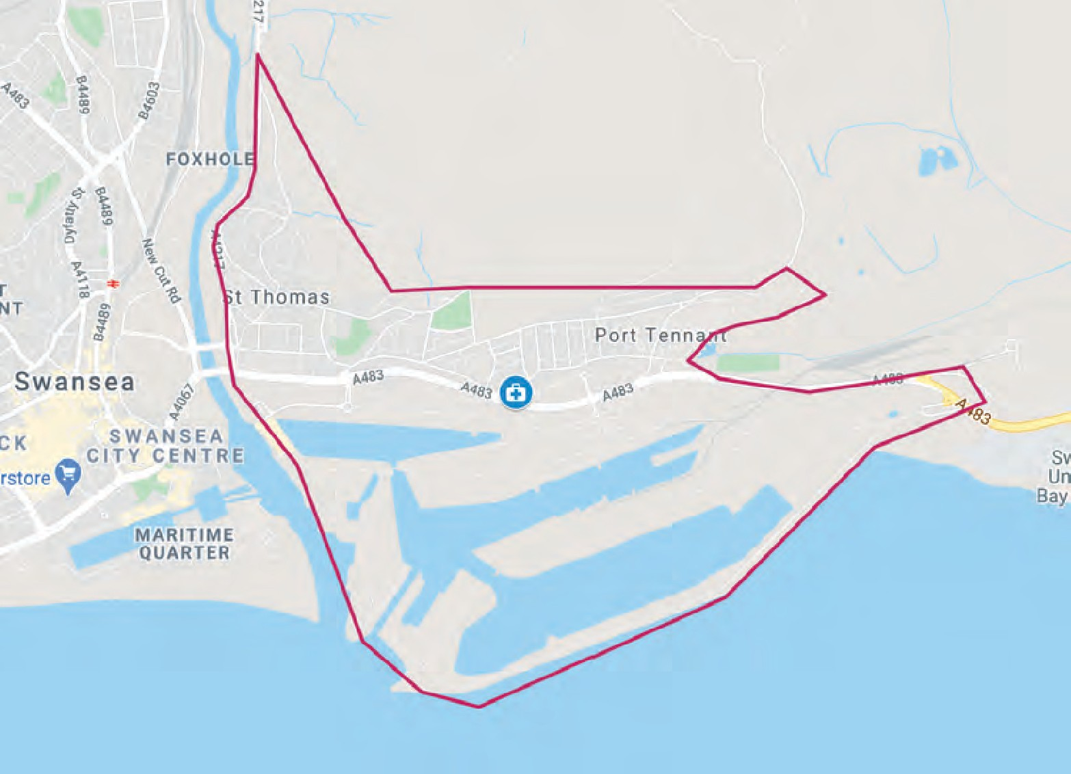

West Cross Medical Centre Boundary

