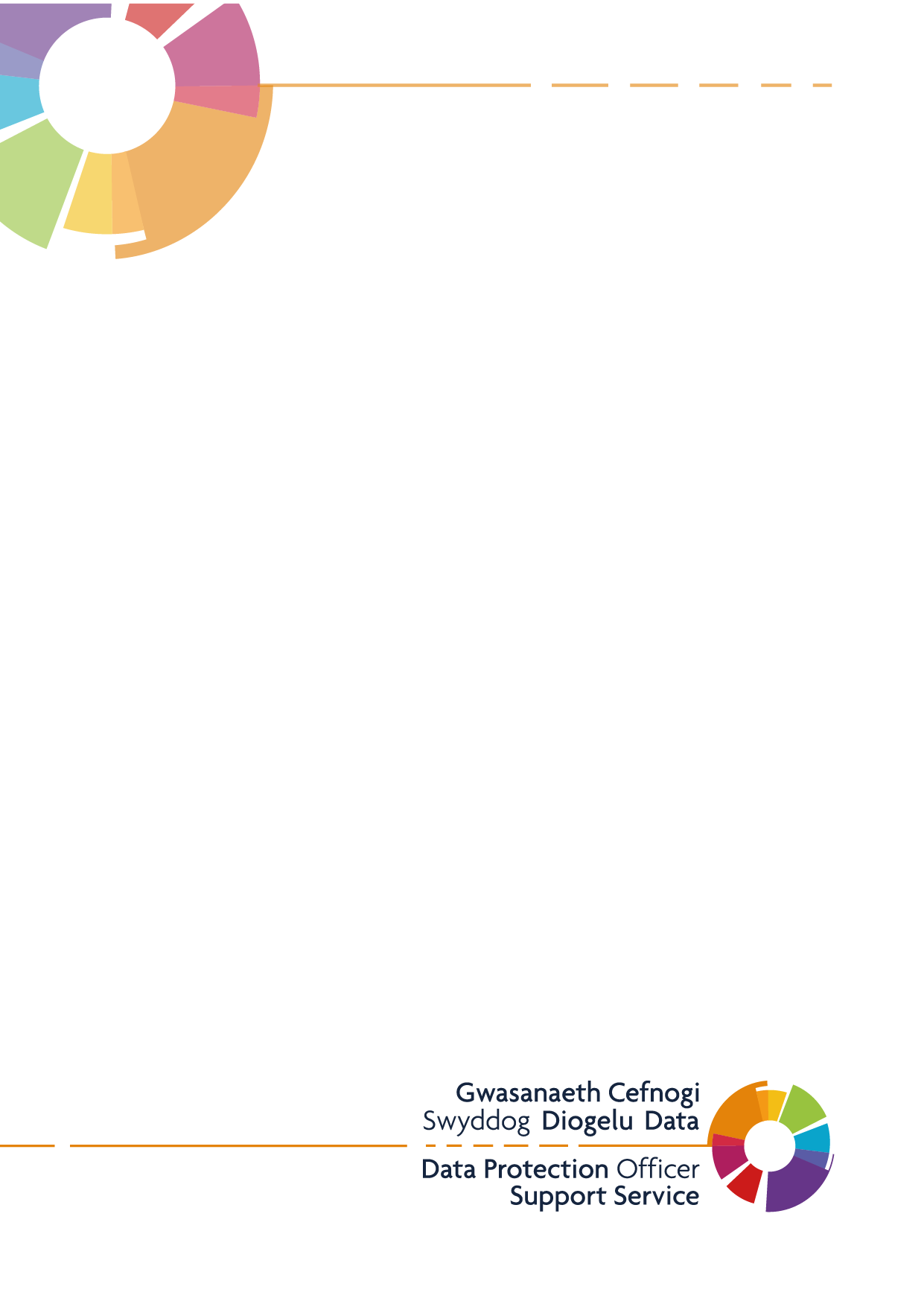

Publication Scheme

St. Thomas Surgery and
West Cross Medical Centre

Introduction
This example publication scheme has been created to outline the types of information that the Practice is expected to publish. The scheme commits St Thomas and West Cross Surgeries to make information available to the public as part of its normal business activities. It allows the practice to be open and transparent, making information under Freedom of Information Act 2000 and environmental information easily and routinely available. By incorporating environmental information into your publication scheme such as policies, plans and procedures relating to the environment, reports on the state of the environment or risk assessments the practice holds, you will also meet your responsibilities to proactively publish environmental information under the Environmental Information Regulations (EIR). The example is based upon the ICO model publication scheme and is broken down into the classes of information required under the Freedom of Information Act 2000. It is recommended that this is laid out in its own section of your Practice’s website, with the below headings listed.
Your Rights to Information
The Freedom of Information Act (FOI) 2000 provides members of the public with the right access information held by public authorities.
Public authorities are required to routinely publish certain information to the public as part of its normal business activities. This is known as a publication scheme.
The St. Thomas Surgery and West Cross Medical Centre Publication Scheme is designed to signpost individuals to information we proactively release as and when it becomes available. The aim of this is to explain what information the practice makes available to the public and where possible to provide an easy method of accessing it.
The Publication Scheme contains seven classes of information, as follows, and information falling into each of these classes is published on our practice website:
- Who we are and what we do
- What we spend and how we spend it
- What are our priorities and how we are doing
- How we make decisions
- Our policies and procedures
- Register of members’ interests
- Services we offer
All the information we proactively release is available free of charge on our website. Our publication scheme is a useful place to start if you’re looking for information about St. Thomas Surgery and West Cross Medical Centre before making a Freedom of Information request.
Information that is not published under the FOI Publication Scheme can be requested in writing and the release of such information will be considered in accordance with the provisions of the FOI Act 2000.
To make a Freedom of Information request, please email contact the practice enquiries.w98016@wales.nhs.uk or write to:
St. Thomas Surgery and West Cross Medical Centre
Ysgol Street
Port Tennant
Swansea, SA1 8LH
Who we are and what we do
St. Thomas Surgery and West Cross Medical Centre is based in Swansea offering primary care servcies to around 9000 patients in the Swansea Bay Cluster Area. We work closely with the other 7 primary care practices in the bay Cluster area more information can be found here Bay Health Cluster - Swansea Bay University Health Board (nhs.wales)
Partners: Dr. W. I. Thomas, Dr. K. Truman, Dr. L. Adams, Dr M Giles
Salaried GPs: Dr. C. Williams, Dr. S. Nicholas Dr M Blyth Dr C Chui
Nurses: Nurse Helen Cooper, Nurse Helen Jones, Nurse Donna Davies, Nurse Kate Hancock
Advanced nurse practitioner Mrs Jessica Huntley
16 supporting admin and reception staff

We are a training practice for GP registrars, Foundation doctors and medical students

Other information is available on the practice website notice boards and display tables in the waiting areas.

What we spend and how we spend it
St. Thomas Surgery and West Cross Medical Centre receives money from NHS Wales according to its contract for national General Medical Services in exchange for services provided for patients.
There may be circumstances where material cannot be released because it is confidential or commercial information or the appropriate officer designated for these purposes, under the Act, has taken the view that it may be prejudicial to the conduct of the Practice’s affairs.
If this is the case, we will respond to your FOI request with a formal letter acknowledging the reasons why we are unable to give you this information.

What our priorities are and how we are doing

The practice is committed to providing a high level of ongoing care to all our patients to the best of our ability despite high demands across all NHS services
We are currently inviting all patient who are over 75 or in high risk categories for their COVID booster.
Working with the cluster and the dietetics service we are involved in identifying patients at risk of diabetes and ensuring they have correct lifestyle advice.

How we make decisions
St. Thomas Surgery and West Cross Medical Centre has a committee that is made up of the senior partners and management.

Our Policies and Procedures
Our Policies and Procedures
General policies and procedures in use within the practice include, but are not limited to:
- Data Protection
- Prescribing
- Zero Tolerance
2) All policies and procedures are available for viewing, upon request in writing, please contact the Practice enquiries.w98016@wales.nhs.uk
3) If you have a complaint or concerns about the service you have received from the doctors or any of the staff working in this practice, please let us know. We operate a complaints procedure as part of the NHS system. Our complaints system meets national criteria.
4) A copy of our practice complaints procedure available Practice Complaints - St Thomas & West Cross Surgery (stthomaswestcross.co.uk)

The services we offer
The services we offer are published on our website St. Thomas & West Cross Medical Centres, Swansea (stthomaswestcross.co.uk)

  - Charges for our private services (including medical reports and travel vaccinations) are published on our website, this information be accessed via NON-NHS Medical Services - St Thomas & West Cross Surgery (stthomaswestcross.co.uk)

The method by which information published under this scheme will be made available
The practice will indicate clearly to the public what information is covered by this scheme and how it can be obtained.
Where it is within the capability of the practice, information will be provided on the website. Where it is impracticable to make information available on a website or when an individual does not wish to access the information by the website, the practice will assist to provide the information in the format it has been requested or offer an alternative method for it to be obtained.

Charges which may be made for information published under this scheme
The purpose of this scheme is to make the maximum amount of information readily available at minimum inconvenience and cost to the public. Charges made by the practice for routinely published material will be justified and transparent and kept to a minimum. Material which is published and accessed on a website will be provided free of charge.
Generally, only the following charges can be made:
- the costs directly incurred as a result of viewing information, photocopying, postage and packaging
- fees permitted by other legislation; and
- for information produced commercially, for example, a book, map or similar publication that you intend to sell and would not otherwise have produced.

